Scroll down to have a glimpse of the swearing in ceremony of the 2004/2006 Executives


President: Tunde Adeyemi
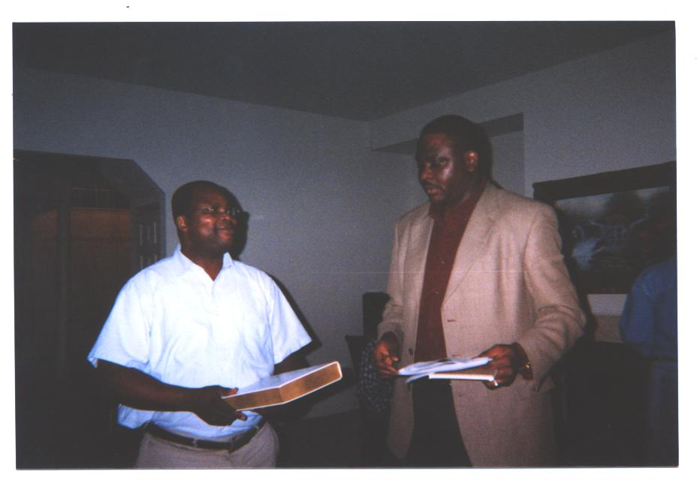
General Secretary: Sola Adeniji


Financial Secretary: Soji Bankole


Assistant General Secretary: Segun Afolabi

Social Secretary: Lekan Salami


Welfare Officer: Niyi Akanni

Assistant Social Secretary: Abiodun Kataiye

